CM1103 L: Computer Systems and Networking

Student ID | 124445
Student Name | BRYAN ADONYE PEPPLE
Course | BSc (Hon) Computing
Academic Year | 2024-2025
Date | 30/04/2025
Time
Duration of the examination | Coursework
No. of Pages (including cover sheet) | 21

Instructions to candidates
(i) Please write your name(s) and student ID on the space provided.
(ii) Answer all questions the MS Word template provided. You are expected to submit two files - an MS Word file and a packet tracer file.
(iii) Upload the coursework and necessary files to Moodle by the deadline.

Special Stationery (if applicable)

Topology
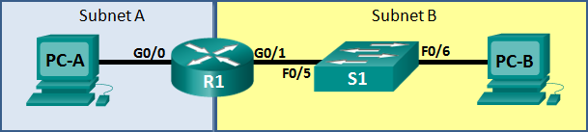
Assessment Objectives
Part 1: Develop the IPv4 and IPv6 Address Scheme
Part 2: Configure Device IPv4/IPv6 and Security Settings
Part 3: Test and Verify IPv4/IPv6 End-to-End Connectivity
Part 4: Use the IOS CLI to Gather Device Information and Configure SSH Access

Scenario
In this coursework you will configure the devices in a small network. You must configure a router, switch and PCs to support IPv4 connectivity. You will configure security on the router. In addition, you will test and document the network using common CLI commands. Packet Tracer should be used to simulate the network.
Required Network Devices and Media:
- 1 Router
- 1 Switch
- 2 PCs
- Console cables for device configuration via console ports.
- Ethernet cables as indicated in the topology.

- Develop the IPv4 and IPv6 Address Scheme
Given an IP address and mask of 192.168.20.0/24 for IPv4 and an IPv6 network segment of 2001:db8: acad:20: :/64, design an addressing scheme that satisfies the following requirements:

Subnet | Number of Hosts
Subnet 1 (IPv4) | 50
Subnet 2 (IPv4) | 10
Subnet 1 (IPv6) | Automatically configure addresses using SLAAC

Use the first subnets. All work on subnetting must be submitted with this document (either in this report, or in a separate word file).
Subnet 1 (IPv4)
Specification | Answer
Number of network bits in the subnet | 26
New IP mask (binary) | 11111111.11111111.11111111.11000000
New IP mask (decimal) | 255.255.255.192
Network IP | 192.168.20.0
First IP Host address | 192.168.20.1
Last IP Host address | 192.168.20.62
Broadcast IP | 192.168.20.63

Explanation for Subnet1
The main aim is to create a subnet that at least supports 50 hosts using IPv4 network 192.168.20.0/24.
Step 1:
Find the number of hosts needed:
Formula for usable hosts per subnet = 2^n - 2 ≥ required hosts
Try values:
= 2^5 - 2 = 30 (Only 30 usable IPs so not enough)
= 2^6 - 2 = 62 (62 usable IPs so enough)
So, we need 6 bits for hosts

Step 2:
Find the new subnet prefix = IP addresses are 32 bits total.
= 32 - 6 = 26 bits for the network.
= new subnet prefix is /26.

Step 3:
Convert /26 to subnet mask:
Firstly, break it into 4 octets (8 bits)
= /26 = 11111111.11111111.11111111.11000000
= 1st octet: 11111111 = 255
= 2nd octet: 11111111 = 255
= 3rd octet: 11111111 = 255
= 4th octet: 11000000 = 192
Binary = 11111111.11111111.11111111.11000000
Subnet Mask = 255.255.255.192

Step 4:
Calculate the total number of IPs addresses in the subnet:
Using this formula = 2^6 = 64
Using 6 bits for hosts:
= Total IPs = 2^6 = 64 (Network address)
= Usable IPs = 64 - 2 = 62 (Broadcast address)

Step 5:
Find the IP Addresses range for the subnet:
Address Type | Value
Subnet | 192.168.20.0/26
Network Address | 192.168.20.0
First Usable Host | 192.168.20.1
Last Usable Host | 192.168.20.62
Broadcast Address | 192.168.20.63

Subnet 2 (IPv4)
Specification | Answer
Number of network bits in the subnet | 28
New IP mask (binary) | 11111111.11111111.11111111.11110000
New IP mask (decimal) | 255.255.255.240
Network IP | 192.168.20.64
First IP Host address | 192.168.20.65
Last IP Host address | 192.168.20.78
Broadcast IP | 192.168.20.79

Explanation for subnet 2:
The main aim of the subnet 2 on the other hand is to create a subnet that at least supports 10 hosts using IPv4 192.168.20.64/28 derived from the original 192.168.20.0/24 network.
Step 1:
Find the number of hosts needed:
Formula for usable hosts per subnet = 2^n - 2 ≥ required hosts
Try values:
= 2^3 - 2 = 6 (Only 6 usable IPs so not enough)
= 2^4 - 2 = 14 (14 usable IPs so enough)
So, we need 4 bits for hosts

Step 2:
Find the new subnet prefix = IP addresses are 32 bits total.
= 32 - 4 = 28 bits for the network.
= new subnet prefix is /28.

Step 3:
Convert /28 to subnet mask:
Firstly, break it into 4 octets (8 bits)
= /28 = 11111111.11111111.11111111.11110000
= 1st octet: 11111111 = 255
= 2nd octet: 11111111 = 255
= 3rd octet: 11111111 = 255
= 4th octet: 11110000 = 240
Binary = 11111111.11111111.11111111.11110000
Subnet Mask = 255.255.255.240

Step 4:
Calculate the total number of IPs addresses in the subnet:
Using this formula = 2^4 = 16
Using 6 bits for hosts:
= Total IPs = 2^4 = 16 (Network address)
= Usable IPs = 16 - 2 = 14 (Broadcast address)

Step 5:
Find the IP Addresses range for the subnet:
Address Type | Value
Subnet | 192.168.20.64/28
Network Address | 192.168.20.64
First Usable Host | 192.168.20.65
Last Usable Host | 192.168.20.78
Broadcast Address | 192.168.20.79

Network routers will use the first IP address in the subnet. The computer will use the LAST network host address. The switch will use the second usable host address.
Write down the IP address information for each device:

Device | IPv4 Address | IPv6 Address | Subnet Mask (IPv4) | Gateway
PC-A | 192.168.20.62 | Automatic via SLAAC | 255.255.255.192 | 192.168.20.1
R1-G0/0 | 192.168.20.1 | SLAAC  prefix for subnet  1 | 255.255.255.192 | N/A
R1-G0/1 | 192.168.20.65 | SLAAC  prefix for subnet  2 | 255.255.255.255 | N/A
S1 | 192.168.20.66 | SLAAC  (auto) | 255.255.255.240 | N/A
PC-B | 192.168.20.78 | Automatic via SLAAC | 255.255.255.240 | 192.168.20.65

- Configure Device IPv4/IPv6 and Security Settings
Configure the router (R1) and switch (S1) for IPv4/IPv6 connectivity and apply basic security configurations such as encrypted passwords and SSH access.

  - Configure host computers.
After configuring each host computer, provide the following information of the host using ipconfig /all command in the command prompt.
PC-A Network Configuration
Physical Address | 00-1B-21-3A-4F-56
IP Address | 192.168.20.62
Subnet Mask | 255.255.255.192
Default Gateway | 192.168.20.1

PC-B Network Configuration
Physical Address | 00-B-21-76-8D-9C
IP Address | 192.168.20.78
Subnet Mask | 255.255.255.240
Default Gateway | 192.168.20.68

  - Configure R1. Configuration tasks for R1 include the following:

Task | Specification | IOS Command | Student Comments
Router name | R1 | hostname R1 | Create the device name R1
Encrypted privileged exec password | ciscoenpass | enable secret ciscoenpass | It encrypts the privileged exec password “ciscoenpass”
Console access password | ciscoconpass | line console 0  password ciscoenpass  login  exit | Secure the console access by assigning a password
Encrypt the clear text passwords | Enable encryption | service password-encryption | Encrypts all plaintexts passwords
MOTD Banner | Message | Banner motd “Unauthorized access is prohibited” | Displays the messages of the day and warn unauthorized users
Interface G0/0 | Set the description.  Set the Layer 3 IPv4 address. Activate Interface | Interface  GagabitEthernet 0/0  description link to subnet 1 (IPV4)  ip address 192.168.20.1 255.255.255.192  no shutdown  exit | Sets up the G0/0 interface for subnet 1 and enable it
Interface G0/1 | Set the description.  Set the Layer 3 IPv4 address. Activate Interface | Interface  GigabitEthernet 0/1  Description link to subnet 2 (IPV4)  Ip address 192.168.20.65 255.255.255.240  No shutdown  exit | Set up the G0/1 interface for subnet 2 and enables it

Configuration tasks for R1 include the following:
Router> enable
Router# configure terminal
Router(config)# hostname R1
R1(config)# enable secret ciscoenpass
R1(config)# line console 0
R1(config-line)# password ciscoconpass
R1(config-line)# login
R1(config-line)# exit
R1(config)# service password-encryption
R1(config)# banner motd #Unauthorized access is prohibited#
R1(config)# interface gigabitEthernet 0/0
R1(config-if)# description Connected to Subnet 1
R1(config-if)# ip address 192.168.20.1 255.255.255.192
R1(config-if)# ipv6 address 2001:db8:acad:20::1/64
R1(config-if)# no shutdown
R1(config-if)# exit
R1(config)# interface gigabitEthernet 0/1
R1(config-if)# description Connected to Subnet 2
R1(config-if)# ip address 192.168.20.65 255.255.255.240
R1(config-if)# no shutdown
R1(config-if)# exit
R1# copy running-config startup-config

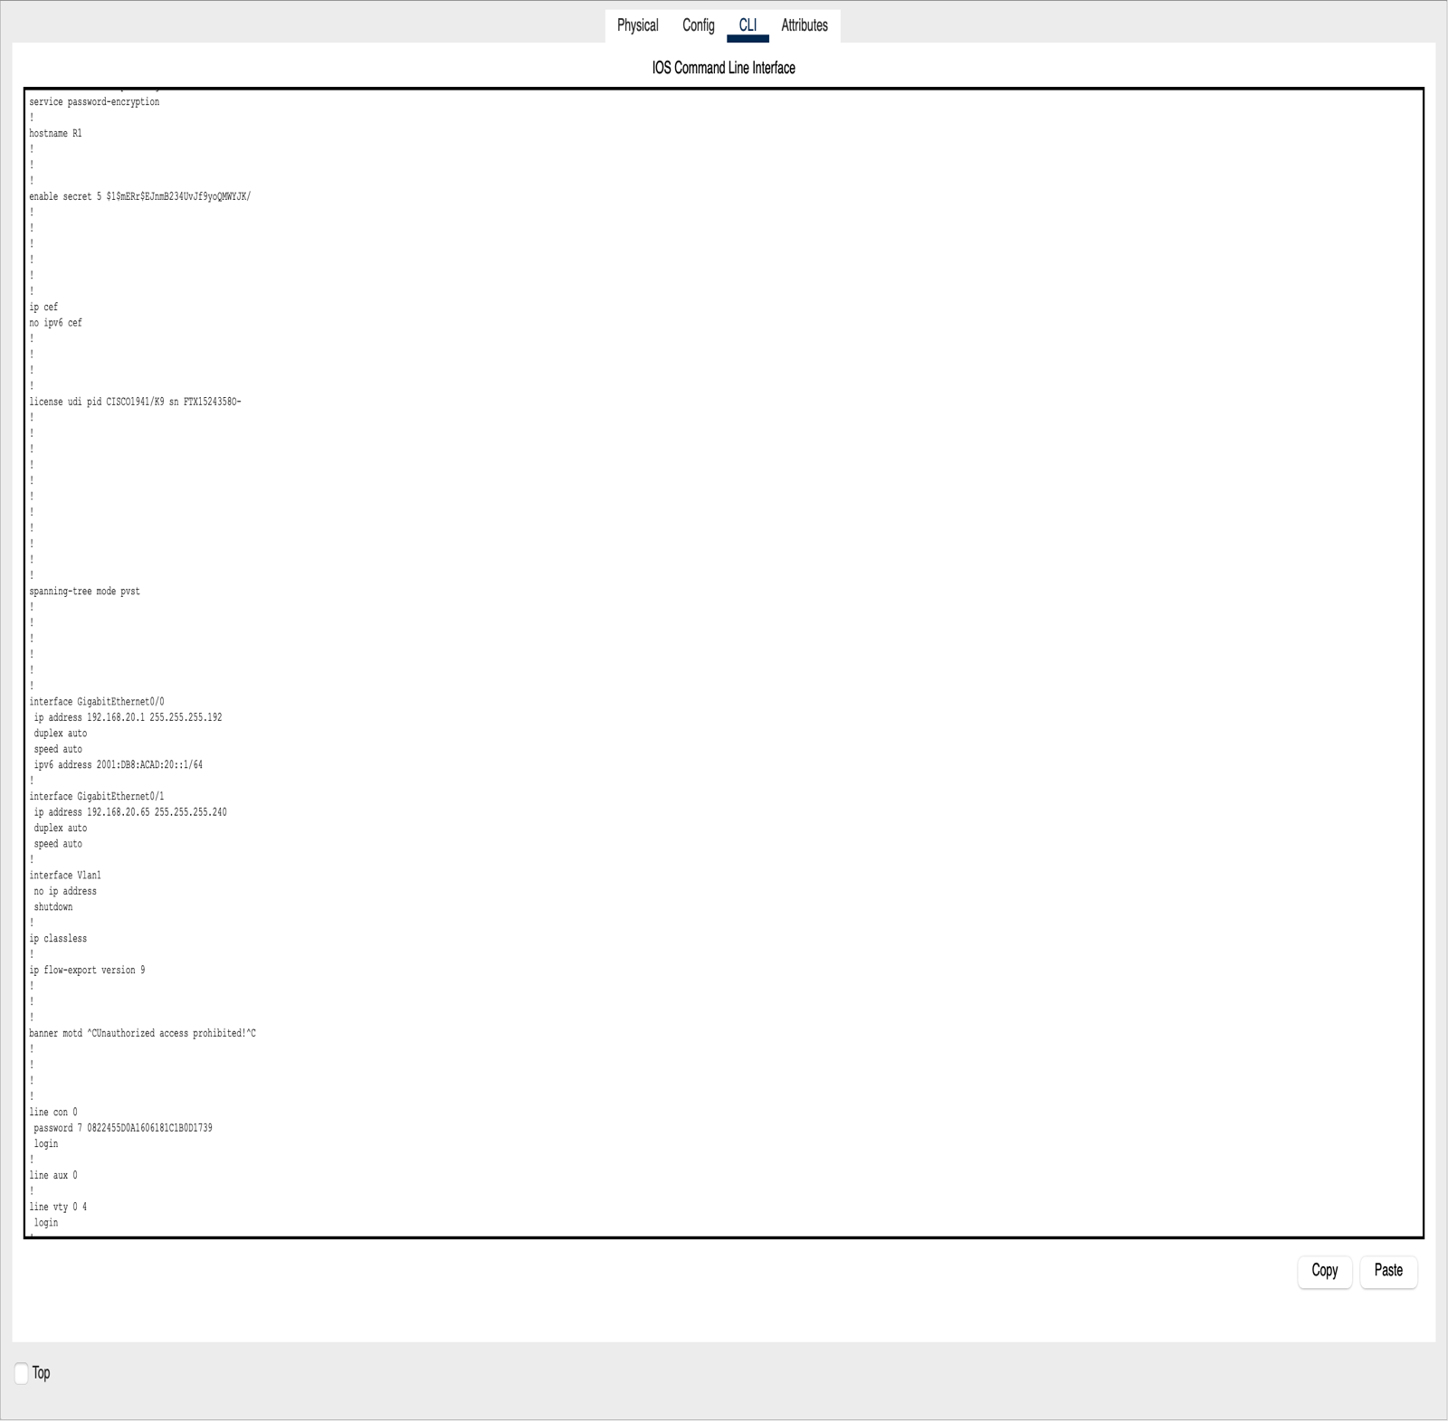
  - Configure S1.
Task | Specification | IOS Command | Student Comments
Switch name | S1 | hostname S1 | Set the device name to S1
Configure Management Interface (VLAN 1) | Set the Layer 3 IPv4 address | interface Vlan1  IP address 192.168.20.66 255.255.255.240  no shutdown  exit | Assign an IP to the switch for remote management
Encrypted privileged exec password | class | enable secret class | It creates an encrypted password for privileged EXEC mode
Console access password | cisco | Line console 0  Password cisco  Login  exit | Secure the console access by assigning a password
Configure Management Interface (VLAN 1) | Repeating IP configuration | Interface Vlan1  IP address 192.168.20.66 255.255.255.240  no shutdown  exit | To confirm the management setting

Configuration tasks for S1 include the following:
Switch> enable
Switch# configure terminal
Switch(config)# hostname S1
S1(config)# enable secret class
S1(config)# line console 0
S1(config-line)# password cisco
S1(config-line)# login
S1(config-line)# exit
S1(config)# service password-encryption
S1(config)# interface vlan 1
S1(config-if)# ip address 192.168.20.2 255.255.255.192
S1(config-if)# no shutdown
S1(config-if)# exit
S1(config)# ip default-gateway 192.168.20.1
S1# copy running-config startup-config

- Test and Verify IPv4/IPv6 End-to-End Connectivity
  - Verify network connectivity.
Perform connectivity tests using ping and traceroute for both IPv4 and IPv6 between all network devices. Document the tests and their outcomes.
Use the following table to methodically verify connectivity with each network device. Take corrective action to establish connectivity if a test fails and provide what those actions were if any:
From | To | IPv4 Address | IPv6 Address | Result/Screenshots
PC-A | R1, G0/0 | 192.168.20.1 | 2001:db8:acad:20::1 | Successful ping
PC-A | R1, G0/1 | 192.168.20.65 | N/A | Successful ping
PC-A | S1 VLAN 1 | 192.168.20.2 | N/A | Successful ping
PC-A | PC-B | 192.168.20.78 | N/A | Successful ping
PC-B | R1, G0/1 | 192.168.20.65 | N/A | Successful ping
PC-B | R1, G0/0 | 192.168.20.1 | 2001:db8:acad:20::1 | Successful ping
PC-B | S1 VLAN 1 | 192.168.20.2 | N/A | Successful ping

- Use the IOS CLI to Gather Device Information and Configure SSH Access
Gather device information using IOS CLI commands and configure SSH access for secure management.
  - Issue the appropriate command to discover the following information:
Description | Answer
Router Model | Cisco 2941(CISCO2901kg)
IOS Image File | C1900-UNIVERSALK9-M), Version 15.1(4)M4,
Total RAM | 491520k
Total Flash Memory | 249856K bytes
Configuration Register | 0x2102(Normal boot)
CLI Command Used | Show version

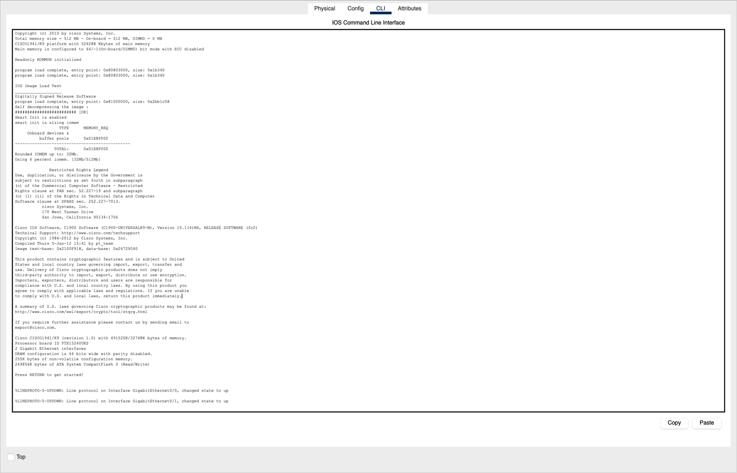

  - Enter the appropriate CLI command needed to display the following on R1:
Command Description | Student Input (command)
Display a summary of important information about the interfaces on R1. | Show ip interface brief:  Summarizes all interface, status, and IP addresses
Display the IPv4 routing table. | Show ip route:  Shows all known IPv4 routes
Display the Layer 2 to Layer 3 mapping of addresses on R1. | Show arp:  Displays the ARP table
Display detailed IPv4 information about interface G0/0 on R1. | Show ip interface g0/0:  Gives detailed setting of interface G0/0 IP
Display the IPv6 routing table. | Show ipv6 route:  Show all known IPv6 routes in the routing table
Display a summary of IPv6 interface addresses and status. | Show ipv6 interface brief:  Summarizes IPv6 addresses and interface status
Save the current configuration so it will be used the next time the router is started. | Copy running-config startup-config:  Saves the current config to NVRAM
- Network Troubleshooting and Best Practices
You have completed the configuration of the network devices and tested the connectivity. However, a user reports that PC-A cannot communicate with PC-B even though both devices have been assigned the correct IP addresses.

Step 1: Identify Possible Causes
List four possible reasons why PC-A might not be able to communicate with PC-B, based on networking principles.
Issues | Explanation
Incorrect IP Address or Subnet Mask | If you input the wrong ip address or subnet mask for PC-A or PC-B, it may lead to poor network communication or connectivity, making it difficult for them to carry out tasks.
Wrong Port Connection | If a device is connected to the wrong switch port or cable is missing/broken, there will be no physical connectivity
Wrong Wiring | If the wrong network cables are used, the device won’t be able to send data, because networks data travel through cables.
Incorrect Gateway | If PC-A or PC-B has the wrong default gateway, packets won’t know how to leave the local subnet to reach the other subnet

Step 2: Troubleshooting Commands
For each issue identified, provide an appropriate CLI command that can be used to diagnose or resolve the problem. Fill in the table below:
Identified Issue | CLI Command to Diagnose or Fix | Expected Output or Resolution
Issue 1 | Show ip interface brief | Interface status should be ‘up up’
Issue 2 | Show running-config | Check interface IP and subnet mask  settings
Issue 3 | Ipconfig /all (PC) or show run (router) | Check if gateway IP is correct
Issue 4 | Show ip route | See if routing table has correct entries

Task 3: Best Practices
Describe three best practices that network administrators should follow to ensure secure and efficient network configurations:
1. Use Strong Passwords and Encrypt it:
Set strong passwords on routers and switches and use commands like service password-encryption to keep them safe. This prevents unauthorized users from easily reading or guessing them.
2. Always Save the Configuration:
After setting up the network, always use copy running-config startup-config to save your work. This makes sure the settings stay even if the device restarts.
3. Label and Document Everything:
Keep clear notes of IP addresses, device names, and cable connections. It makes troubleshooting easier and helps other understand the network setup.

Additional Information
If you need to add any more information, e.g. issues faced and how you solved them, you may use this section.
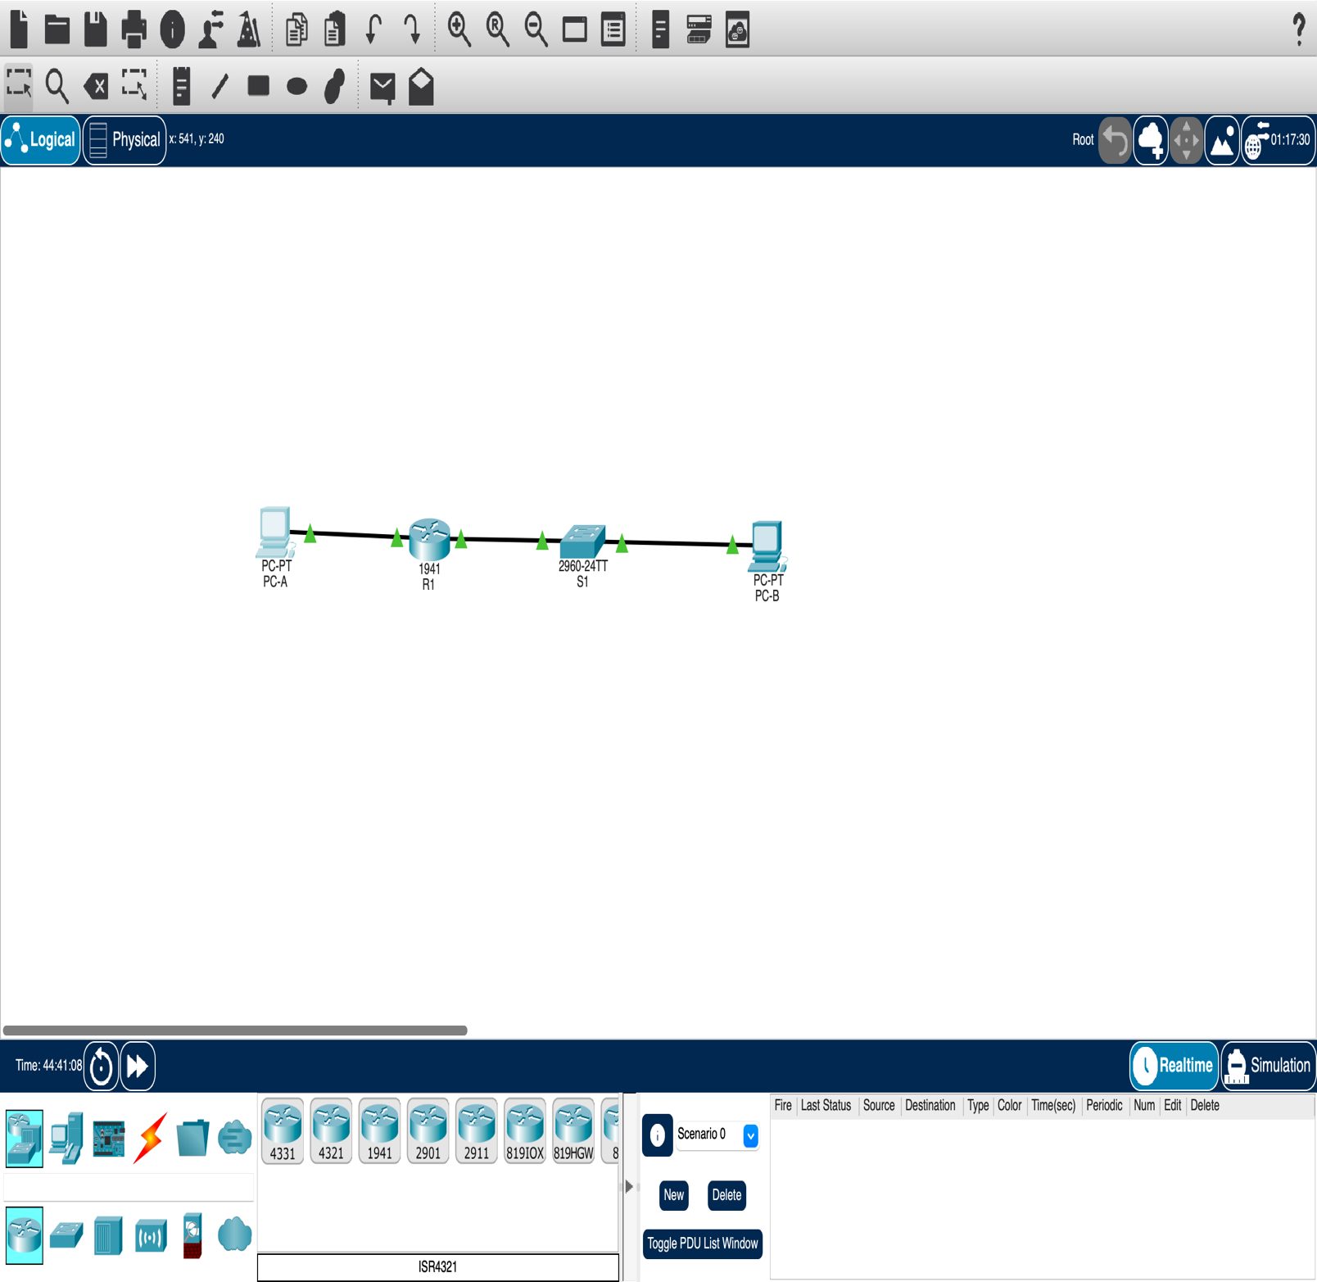
Marking Grid

GRADE | A | B | C | D | E | F | NS
DEFINITION | EXCELLENT Outstanding Performance | COMMENDABLE Meritorious Performance | GOOD  Highly Competent  Performance | SATISFACTORY Competent Performance | BORDERLINE FAIL Open To Compensation | FAIL Unsatisfactory | NON-SUBMISSION
Network Report | Complete and Comprehensive report, all parts are done correctly and comprehensively, all commands are correctly justified and commented on logically, and all network components works fine. | Complete report, most parts are done correctly, most commands are correctly justified and commented on logically, and most network components works fine. | Complete report, most parts are done correctly, few commands are correctly justified and commented on logically, and some network components works fine. | Incomplete report, few parts are done correctly, few commands are correctly justified and commented on logically, and some network components works fine. | Incomplete report, few parts are done correctly, few or no commands are correctly justified and commented on logically, and there is no network connectivity | Incomplete report, no parts are done correctly, no commands are correctly justified and no comments are provided, with no network connectivity at all. | No report is provided.

Stateless Address Auto-Configuration (SLAAC) can automatically configure IPv6 host parameters on an IPv6 host without the need for manual configuration or a DHCP server.

